

Projektmanagement und Teamorientiertes Projekt

Team 4: HACKLAB

Summarise all used Resources.

1. **Attack and defence Scenarios search**
2. [Tobias, 2014] Tobias, H. (15.01.2014) Bachelorarbeit: Grundlegende Techniken der praktischen IT-Sicherheit aus Angreifersicht. <https://libdoc.fh-zwickau.de/opus4/frontdoor/deliver/index/docId/8942/file/Bachelorarbeit_Tobias_Heinlein_15012014.pdf>

In this file, just point 7 was useful to us, when we wanted to determine how some of the attacks we should play would be implemented.

**For example:**

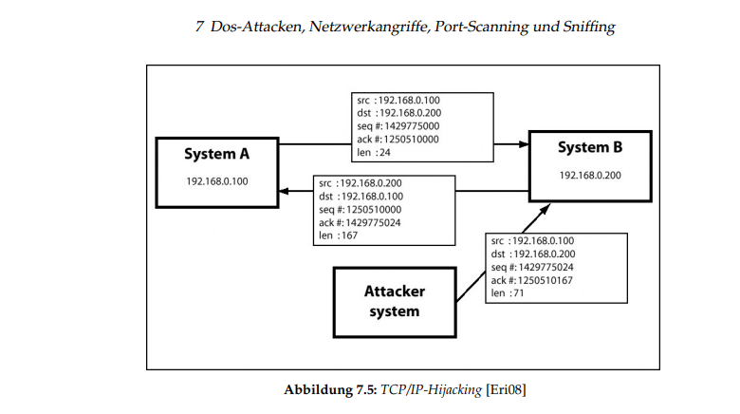

Another file that helped us to refresh our knowledge about the attack scenarios and how they are then implemented.

1. [Hughes, 2014] Hughes C. Angriffsszenarien: Die 8 Häufigsten Angriffsszenarien. <https://wi.uni-potsdam.de/homepage/lehrewi.nsf/0/CC9D442FC6DE536AC12581D200495D70/$FILE/Angriff%20und%20Verteidigung.pdf> (Last Stand: 21.02.2022).
2. **LXD-Container**

Our containers, which are started at every level, are networked together with a bridge. This page helped us understand how to configure the bridge

1. [Zefanja, 2019] Zefanja (07.02. 2019) ZEFANJAS: Netzwerkbrücke für lxd Container. <https://zefanjas.de/netzwerkbruecke-fuer-lxd-container-einrichten/> (Last Stand: 21.02.2022).
2. <https://linuxcontainers.org/lxc/getting-started/#creating-unprivileged-containers-as-a-user> (Last Stand: 22.02.2022)
3. **Shell- and Ansible scripting**

We had to automate the creation of our containers so that they can only be created with one command. For this we then needed scripts. This page were also helpful to us for this.

1. [Bart, 2017] Bart (26.04.2017) How to use LXD (Linux containers) in a shell script. <https://www.cyberciti.biz/faq/how-to-create-lxd-vm-when-the-cloud-instance-launches/> (Last Stand: 21.02.2022).

[Red Had, 2017] Red Had (01.12.2020) Ansible: lxd_container - Manage LXD Containers. <https://docs.ansible.com/ansible/2.4/lxd_container_module.html> (Last Stand: 21.02.2022).

[Codeberg,2021] Codeberg. Ansible: Ansible role to install LXD server and setup LXD containers <https://codeberg.org/ansible/lxd-server> (Last Stand: 21.02.2022).

[Kevin, 2021] Kevin C. (21.12.2021) Ansible: Lxd Container Manage. <https://docs.ansible.com/ansible/latest/collections/community/general/lxc_container_module.html> (Last Stand: 21.02.2022).

<https://docs.ansible.com/ansible/latest/user_guide/playbooks_variables.html> (Last Stand: 22.02.2022)

1. **Alpine ISO:**

The goal was to create containers that are safe. That's why we thought we would then take a snapshot and create an image from it, (in our case Alpine, because it requires little storage space). This image should then be a template for the other containers, as we also have many containers. So on the following page you will find a detailed order of how this becomes possible

1. <https://techgoat.net/index.php?id=60> (Last stand:22.02.2022)

on this Page you will find an introduction to how to use Alpine Linux.

1. <https://wiki.alpinelinux.org/wiki/Package_management> (Last Stand: 22.02.2022).

In order to be able to play through our attacks and Defence, we need some tools that help us with monitoring, management, control and security. Lynis is a tool that is responsible for performing security checks in the Linux environment. More information about it and how it is operated can be found on the following page

1. <https://cisofy.com/documentation/lynis/get-started/#installation-git> (Last Stand: 22.02.2022).